Information For Parents About Reading

At Creech St. Michael Primary School we have a holistic approach to reading. We therefore place equal emphasis on word recognition and language comprehension. Reading is seen as a partnership between home and school and as soon as they start school, children take home self-chosen story books to share with parents. They are also issued with pre-word texts to encourage early story language and book related vocabulary.
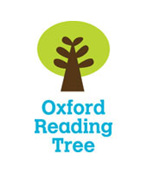
Phonics is taught through ‘Read, Write, Inc.’ and as children progress through the scheme, they are given decodable texts that match their phonic stage. 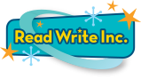
The main reading scheme we use is Oxford Reading Tree.

We do, however, also provide children with books from other reading schemes in order to give them experiences reading a variety of texts and genres, both fiction and non-fiction. Children are provided with a range of adventurous vocabulary through carefully selected texts and they practise reading comprehension skills during Read, Write, Inc., in group reading sessions and when reading their home-school reading books.

