Division Progression Poster
2018

Language to be used:
Foundation
share, share equally, one each, two each…, group, groups of, lots of.
Key Stage One
group in pairs, 3s … 10s etc, equal groups of, divide, ÷, divided by, divided into, remainder
Lower Key Stage Two
divide, divided by, divisible by, divided into, share between, groups of, factor, factor pair, multiple, times as (big, long, wide …etc), equals, remainder, quotient, divisor and inverse
Upper Key Stage Two
As above and common factors, prime number, prime factors, composite numbers, short division, square number, cube number, inverse, power of

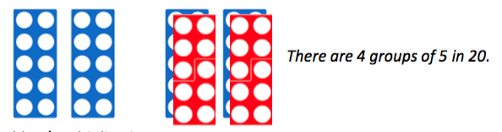
Foundation Stage
Children will understand equal groups and share items out in play and problem solving. They will count in 2s and 10s and later in 5s. Halve objects and numbers by sharing.

Year One
Halving by sharing and simple division by grouping objects
Begin to find a quarter by halving and halving again

Year Two
Need to understand division as grouping, how many groups of and introduction to remainders. Use the same visual models of arrays as multiplication.

Year Three
Divide 2 digit by 1 digit progressing from mental to formal written methods

Year Four
Divide 2 digit by 1 digit and 3 digit by 1 digit using formal written methods

Year Five
Divide numbers up to 4 digits by one digit (and also 11 and 12) using the formal ‘bus stop’ written method of short division and interpret remainders as appropriate to the context.

Year Six
Divide numbers up to four digits by 2 digit numbers using the formal ‘bus stop’ written method of SHORT division and interpret remainders as decimals up to 2.d.p, fractions and whole numbers – don’t forget the key!

