Multiplication Progression Poster
CSM 2018

Language to be used:
Foundation
groups of, lots of.
Key Stage One
multiple, multiplication array, multiplication tables / facts, groups of, lots of, times, columns, rows
Lower Key Stage Two
multiple, partition, short multiplication, inverse, factor and product
Upper Key Stage Two
cube numbers, prime numbers, square numbers, common factors, prime number, prime factors and composite numbers

Multiplication Fact Recall

FoundationCount in 2,5 and 10’s
Year OneCount forwards and backwards in multiples of 2,5 and 10’s
Year Two2,5 and 10 tables
Year Three 3,4 and 8 tables
Year Four12 x 12 tables


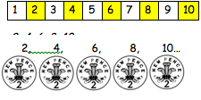
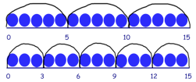
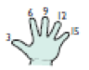
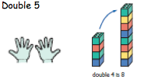
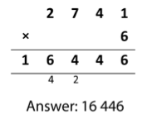
Foundation Stage
They will count in 2s and 10s and begin the count in 5s. They will work on practical problem solving activities involving equal sets or groups. Double objects and numbers.

Year One
Double single-digit numbers, then to 30
Count on in steps (2s, 5s, 10s)
Record as repeated addition and an array

Year Two
Recall and use multiplication and division facts for the 2, 5 and 10
Use commutativity – 5x3 same as 3x5
Double two-digit numbers

Year Three
Recall 3, 4 and 8 times tables facts
Multiply 2 digit by 1 digit progressing from mental to formal written methods

Year Four
Recall 12 x 12 times tables facts
Multiply 2 digit by 1 digit and 3 digit by 1 digit using formal written methods

Year Five
Multiply up to 4 digit number by 1 digit or 2 digits using formal written methods, including long multiplication for 2 digit numbers

Year Six
Multiply multi digit numbers up to 4 digits by 2 digit number using long multiplication.
Multiply one digit numbers with up to 2.d.p by whole numbers.

