Subtraction Progression Poster
2018

Language to be used:
Foundation
take away, less, minus, subtract, leaves, difference between, how many more, how many fewer / less than, most, least, count back , how many left, how much less is_?
Key Stage One
Subtraction, subtract, take away, difference, difference between, minus, less than, one less, two less… ten less…
Lower Key Stage Two
less, minus, decrease, fewer, difference, how many less to make..? how much less? ones boundary, tens boundary, hundreds boundary, thousands boundary, tenths boundary, hundredths boundary, inverse, how many fewer? Equals sign, is the same as.
Upper Key Stage Two
As above

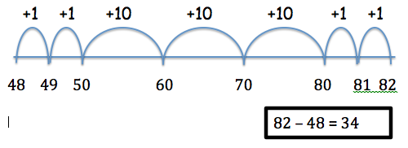
Year Five
Subtract pairs of four digits and up to two decimal places.
Children still use number line to find the difference, counting on OR counting back.

Year Six

Foundation Stage
Bead strings can be used to illustrate subtraction by counting back a single digit subtract a single digit or counting on.

Year One
Count back, first in ones then using number facts. Two-digit take one-digit, comparing quantities to find the difference.

Year Two
Two-digits subtract two-digits, counting on to find the difference using a number line, and using practical apparatus and pictures alongside the formal written method for subtraction.

Year Three
Subtract numbers with up to three digits, using the formal written methods of columnar subtraction
Children to still use number line to find the difference

Year Four
Subtract numbers with up to 4 digits using the formal written methods of columnar subtraction.
Children to still use number line to find the difference

- Children now use compact method of subtraction.
- Subtraction of decimals up three decimal places, with differing place values.

