|  |  |  |
| --- | --- | --- |
| **Creech St Michael Primary School** | | |
| **Science: Physics** | **Light & Shadow** | **Year 3 / 4** |

|  |
| --- |
| **Background understanding (what I should already know)…** |
| * name different light sources * an object in front of the sun can make a shadow * how to make shadow puppets |

|  |  |
| --- | --- |
| **Key vocabulary** | |
| **Light** | light is a type of energy that makes it possible for us to see the world around us.  light source. |
| **Light source** | an object that emits light |
| **Light beam** | a projection of light energy radiating from a light source. |
| **Dark/ darkness** | the absence of light in a place. |
| **Reflection** | when light hits the surface of an object and then that light travels to our eyes so we can see. |
| **Opaque** | a material you are not able to see through (not transparent). |
| **Transparent** | a material allowing light to pass through so that objects behind can be seen clearly. |
| **Shadow** | an area of darkness produced by an object coming between rays of light and a surface |
| **Translucent** | a material allowing light, but not detailed shapes, to pass through (semi-transparent). |
| **Torch** | a portable battery-powered electric lamp.  mirror a surface, typically glass coated with metal, which reflects a clear image. |
| **Source** | where something comes from. |
| **Sunglasses** | glasses with dark lenses which you wear to protect your eyes from  bright sunlight. |
| **Protect** | to keep from being harmed either by covering or shielding. |
| **Illuminate** | a verb meaning to light up. E.g. A flash of light illuminated thehouse. |
| **Spectrum** | A range of colours caused when white light is refracted. A rainbow shows a spectrum of colours. |
| **Rainbow** | An arch of colour caused by the refraction of light on water droplets in the air, usually rain (Red, Orange, Yellow, Green, Blue, Indigo, Violet). |

|  |  |
| --- | --- |
| **What I will know by the end of the unit…** | |
| **Light beams are projected from the light source (the sun)** | These light beams travel in a straight line until they meet an object. The light beams are then reflected off the surface it meets, until the light beam enters the eye (see picture). The light activates cells inside our eyes which are processed by our brain into an image. This all happens incredibly fast! All of the objects we can see are only visible when light has reflected from the objects |
| **Sun Safety** | Sunlight can damage your eyes.  Protect them by wearing  sunglasses or a hat. NEVER look  directly at the sun |
| **Darkness – and how shadows are formed?** | Darkness is the absence of light.  A shadow is an area of darkness produced by an object coming between beams of light and a surface.  They look different depending on the transparency of the object. Transparent objects = faint shadows  (more light gets through).  Translucent objects = darker than transparent, lighter than opaque object shadows.  Opaque objects = dark shadows.  The distance between the object and the light  source, near or far / high or low, will affect the size of the shadow. |
| **How does light travel?** | Light travels in a straight line |
| **Does light travel faster than sound?** | Light travels faster than sound. |
| **Does the size and shape of the shadow change?** | The size and shape of a shadow changes based on the distance  and angle compared to the light source. |
| **Is the moon a light source?** | The moon does not emit its own light – it reflects the sun |
| **What is ultraviolet (UV) light?** | Ultraviolet (UV) light is a type of radiation which you can’t see  but can be dangerous. UV rays can come from the sun |

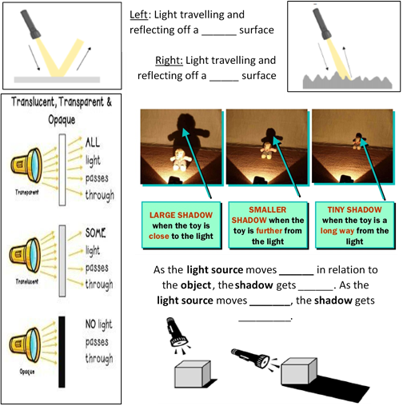

**Scientific skills and enquiry (Year 3 and 4)**

* Ask relevant questions and use different types of scientific enquiries to answer them.
* Set up simple practical enquiries, comparative and fair tests.
* Make systematic and careful observations and, where appropriate, take accurate measurements using standard units, using a range of equipment, including thermometers and data loggers.
* Record findings using simple scientific language, drawings, labelled diagrams, keys, bar charts and tables.
* Gather, record, classify and present data in a variety of ways to help in answering questions.
* Identify differences, similarities or changes related to simple scientific ideas and processes.
* Report on findings from enquiries including oral and written explanations, displays or presentations of results and conclusions.
* Use straightforward scientific evidence to answer questions or to support their findings.
* Use results to draw simple conclusions, make predictions for new values, suggest improvements and raise further questions.

|  |
| --- |
| **Working Scientifically: Possible Investigations** |
| * looking for patterns in what happens to shadows when the light source moves or the distance between the light source and the object changes. * Pupils should explore what happens when light reflects off a mirror or other reflective surfaces, including playing mirror games to help them to answer questions about how light behaves. They should think about why it is important to protect their eyes from bright lights. They should look for, and measure, shadows, and find out how they are formed and what might cause the shadows to change. |
| **Famous Scientist**  **Ibn al-Haytham** was born in 965BC in what is now present day Iraq. He was the first person to prove that we see because light reflects off objects and into our eyes. He was also one of the first thinkers to use a scientific method.  A person with a beard  Description automatically generated with medium confidence |