|  |  |  |
| --- | --- | --- |
| **Creech St Michael Primary School** | | |
| **Science: Biology** | **Animals including humans**  **(Nutrition and Skeleton)** | **Year 3 / 4** |

|  |
| --- |
| **Background understanding (what I should already know)…** |
| * **notice that animals, including humans, have offspring which grow into adults** * **find out about and describe the basic needs of animals, including humans, for survival (water, food and air)** * **describe the importance for humans of exercise, eating the right amounts of different types of food, and hygiene** |

|  |  |
| --- | --- |
| **Key vocabulary** | |
| **Balanced diet** | A variety of food that you regularly eat |
| **Diet** | The type and range of food that you regularly eat |
| **Energy** | The ability and strength to do physical things |
| **Heathy** | Well and not suffering from illness |
| **Nutrients** | Substances that help plants and animals to grow |
| **Nutrition** | The process of taking food into the body and absorbing the nutrients in those foods |
| **Starchy** | Foods that contain a lot of starch (a **nutrient** which gives you **energy**) |
| **Backbone** | The column of small-linked **bones** down the middle of your back. Also known as a spine |
| **Bones** | The hard parts inside your body which form your **skeleton** |
| **Contract** | To make smaller by drawing together; shrink or make tighter |
| **Endoskeleton** | The internal **skeleton** of an animal, especially the bony **skeleton** of **vertebrates** |
| **Exoskeleton** | The **protective** or **supporting** structure covering the outside of the body of many animals |
| **Joints** | The junction between two or more bones |
| **Muscles** | Something inside your body which connects two bones and which you use when you make a movement |
| **Organs** | A part of your body that has a particular purpose |
| **Protect** | **Protecting** someone or something means to prevent them from being harmed or damaged |
| **Relax** | When a part of your body **relaxes,** or when you relax it, it becomes less stiff or firm |
| **Skeleton** | The framework of **bones** in your body Skeletons are important to **protect organs** inside the body, **allow movement** and **support** the body. |
| **Tendons** | A strong cord in a person’s or animals body which joins a muscle to a bone |
| **Vertebrate** | A creature which has a spine |

|  |  |
| --- | --- |
| **What I will know by the end of the unit…** | |
| **What are the different types of food and nutrients?** | **There are more than 40 different kinds of nutrients in food. Generally, they can be classified into the following 7 major groups:**   * **Carbohydrates.** * **Proteins.** * **Fats.** * **Vitamins.** * **Minerals.** * **Dietary fibre.** * **Water** |
| **What are the different types of skeletons?**  **Endoskeleton** | * **Vertebrates (including humans) have an endoskeleton.** * **This means vertebrates have a skeleton on the inside the body that supports and protects it.** |
| **Exoskeleton** | * **Exoskeleton are animals with a skeleton on the outside of the body that supports and protects it.** |
| **Hydrostatic Skeleton** | * **A skeleton made up of a fluid-filled compartment in the body called a coelom, mainly found in soft-bodied animals** |
| **How do we move?** | **Muscles attach to bones by tendons, which helps them to move. Skeletal muscles work in pairs to move the bones. When one muscles contracts (it shortens) - the other muscles relaxes (gets longer or returns to its normal size).** |

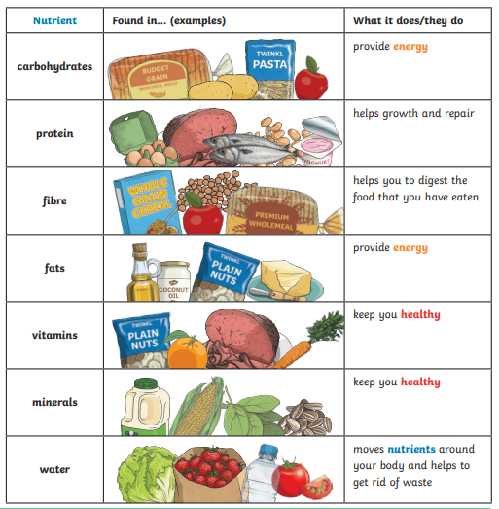

|  |
| --- |
| **Working Scientifically: Possible Investigations** |
| * **Compare and contrast the diets of different animals (including their pets) and decide ways of grouping them according to what they eat** * **Research how different foods contribute to a varied diet** * **Design meals based on your research** * **Identify and group animals with and without skeletons and compare the ways in which they move** * **Match animals to their skeletons and explain your reasons for this** * **Identify which bones are used for support, which bones are used for protection** |

**Scientific skills and enquiry (Year 3 and 4)**

* Ask relevant questions and use different types of scientific enquiries to answer them.
* Set up simple practical enquiries, comparative and fair tests.
* Make systematic and careful observations and, where appropriate, take accurate measurements using standard units, using a range of equipment, including thermometers and data loggers.
* Record findings using simple scientific language, drawings, labelled diagrams, keys, bar charts and tables.
* Gather, record, classify and present data in a variety of ways to help in answering questions.
* Identify differences, similarities or changes related to simple scientific ideas and processes.
* Report on findings from enquiries including oral and written explanations, displays or presentations of results and conclusions.
* Use straightforward scientific evidence to answer questions or to support their findings.
* Use results to draw simple conclusions, make predictions for new values, suggest improvements and raise further questions.