|  |  |  |
| --- | --- | --- |
| **Creech St Michael Primary School** | | |
| **Science: Chemistry** | **Rocks, Fossils and Soils** | **Year 3 / 4** |

|  |
| --- |
| **Background understanding (what I should already know)…***taught in Geography topic Y3/4* |
| * **There are three basic types of rock: igneous, sedimentary, and metamorphic.** * **Extremely common in the Earth’s crust, igneous rocks are volcanic and form from molten material.** * **Rock is a natural substance.** |

|  |  |
| --- | --- |
| **Key vocabulary** | |
| **Rock** | A rock is a solid collection of mineral grains |
| **Sedimentary rock** | Formed when sand, mud and pebbles are laid down in layers. Over time, they are squashed under more layers. Eventually, they are lithified (turned into rock). |
| **Igneous rock** | Rocks that has been formed from magma or lava. |
| **Metamorphic rock** | Rocks that started out as igneous or sedimentary but changed due to extreme heat or pressure. |
| **Soil** | The upper layer of Earth where plants grow, |
| **Fossil** | The hard remains of a prehistoric animal or plant that are found inside rock. |
| **Permeable** | Allows water and gas to pass through it. |
| **Absorbent** | Able to soak up liquid |
| **Decompose** | Become rotten and starts to break down. |
| **Compress** | Squeezed or pressed by pressure. |
| **Melting** | Becoming a liquid by heat. |
| **Cooling** | Becomes less hot. |

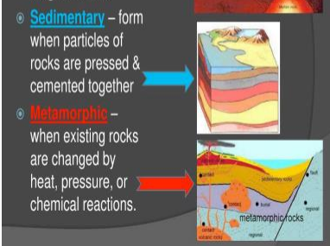

|  |
| --- |
| **Mary Anning (21 May 1799 – 9 March 1847) was an English fossil collector, dealer, and palaeontologist who became known around the world for the discoveries she made in Jurassic marine fossil beds in the cliffs along the English Channel at Lyme Regis in the county of Dorset in Southwest**  **What I will know by the end of the unit…** |
| **• Know how rocks and mountains are formed** |
| **• Classify and group different types of rock** |
| **• Explain the changes that can happen to rocks through weathering** |

