

Creech St Michael Primary School
Subject:  Biology | Living Things – Habitats and Classification | Year 5/6

Background understanding (what I should already know)…
Animals including humans
- I can identify and name a variety of common animals including fish, amphibians, reptiles, birds and mammals
- I can Identify and name a variety of common animals that are carnivores, herbivores and omnivores
- I can describe and compare the structure of a variety of common animals (fish, amphibians, reptiles, birds and mammals, including pets)
What: (key vocab)
Amphibian | Amphibians are vertebrate animals (have a backbone)
Annelids | Animals that have no legs, and no hard skeleton.
Bacteria | Bacteria are single-celled, or unicellular organisms.
Botanist | Scientists who study plants
Characteristics | Characteristics are the distinguishing features or quality of something
Crustacean | Crustaceans are animals that usually have a hard covering, or exoskeleton, and two pairs of antennas, or feelers
Fungus | A fungus is a simple organism, or living thing, that is neither a plant nor an animal. When there is more than one fungus they are called fungi
Mammal | Mammals include humans and all other animals that are warm-blooded vertebrates (vertebrates have backbones) with hair.
Micro-organism | Microorganisms are very tiny living things. They are so small that you need a microscope to see them.
Mollusc | A mollusc is an invertebrate (meaning it has no backbone). Molluscs have very soft bodies and are massively diverse. Many have shells
Non-vascular (plants) | They are plants that lack a vascular tissue system. They have no flowers, leaves, roots, or stems.
Organism | An individual plant, animal or single-celled life form.
Vascular (plants) | These plants possess vascular tissues; these plants have true stems, leaves, and roots.
What I will know by the end of the unit…
Linnaeus Classification System | The system for classifying plants and animals and the system for naming all living things.  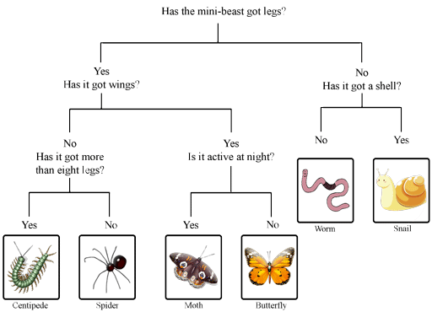
Identifying and grouping micro-organisms | There are five types of living microorganisms; these include bacteria, viruses, fungi, algae and protozoa.  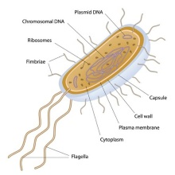
Classify plants according to their characteristics | Plants fall into four categories: With seeds or without seeds; flowering plants, conifers, ferns and mosses.  . 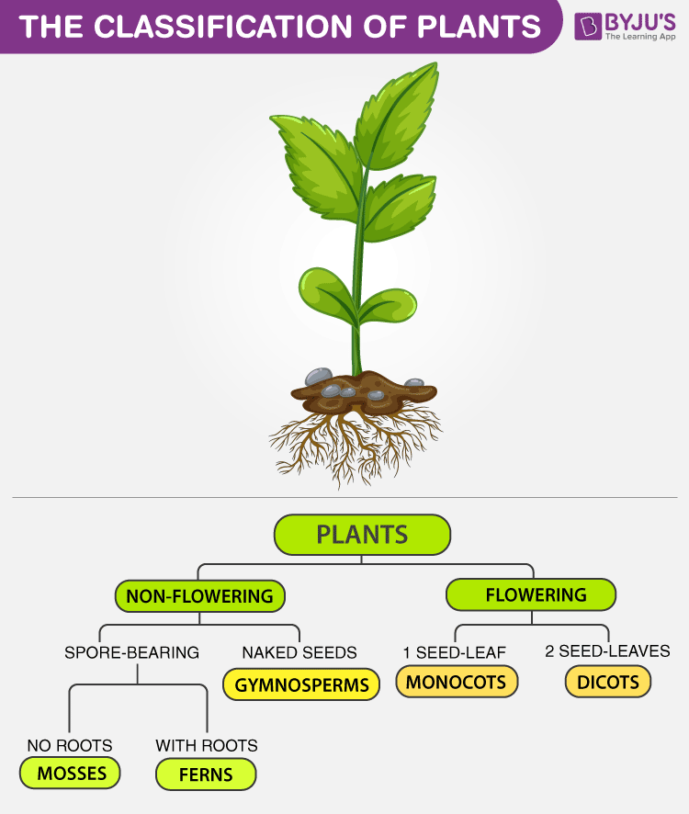

Who: (famous people)

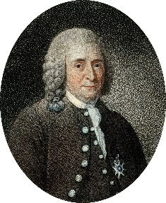  Carl Linnaeus  1707 - 1778 | One of the first scientists to create a classification system.
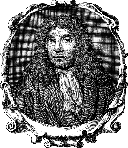  Antonie van Leeuwenhoek  1632 - 1723 | Leeuwenhoek is known as the first microbiologist because he was the first to observe bacteria underneath a microscope.
Possible Scientific Enquiry Questions…
Fair testing | Do all flowers have the same number of petals?
Identifying, classifying and grouping | Can you group a selection of livings things?  Why is your invertebrate a member of the …. group? Why could it not fit within a different group?
Scientific skills and enquiry (Year 5 and 6)
- Identifying scientific evidence that has been used to support or refute ideas or arguments.
- Planning different types of scientific enquiries to answer questions, including recognising and controlling variables where necessary.
- Taking measurements, using a range of scientific equipment, with increasing accuracy and precision, taking repeat readings when appropriate.
- Recording data and results of increasing complexity using scientific diagrams and labels, classification keys, tables, scatter graphs, bar and line graphs.
- Using test results to make predictions to set up further comparative and fair tests.
- Reporting and presenting findings from enquiries, including conclusions, causal relationships and explanations of and degree of trust in results, in oral and written forms such as displays and other presentations.

