

Creech St Michael Primary School
Science  Biology | Living Things and Habitats | Year  2

Background understanding (what I should already know)…
- Understanding the world ELG: The Natural World – Explore the natural world around them, making observations and drawing pictures of animals and plants.
- The Natural World – Know some similarities and differences between the natural world around them and contrasting environments, drawing on their experiences in class.
- Trips and visitor experiences: habitats, farms
What I will know by the end of the unit…
Explore and compare the differences between things that are living, dead, and things that have never been alive. | Identify and name a variety of plants and animals in their habitats, including microhabitats.
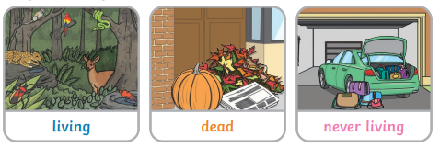 | 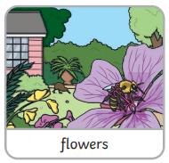  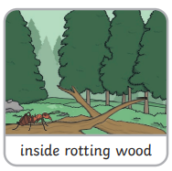  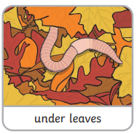
Identify that most living things live in habitats to which they are suited | Describe how animals obtain their food from plants and other animals, using the idea of a simple food chain, and identify and name different sources of food
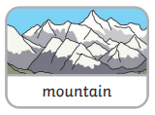  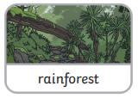  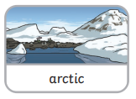  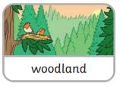  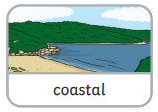  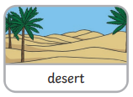 | 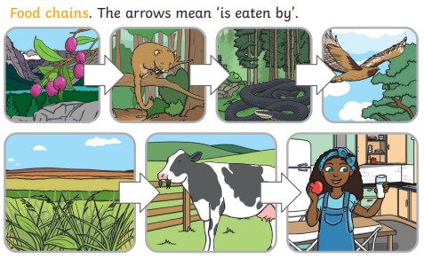

Key vocabulary
Dead | Things that were once living (they did have all the life processes but do not now).
Depend | If you depend on someone or something, you need them in order to be able to survive
Environment | The area in which something exists or lives
Food chain | A series of living things linked to each other because each thing feeds on the one next to it in the series (the arrow means ‘it is eaten by’).
Habitat | The natural environment in which an animal or plant normally lives or grows
Life Processes | All the things that living things do: breathe, sense, grow, move, reproduce (have babies), excrete (get rid of waste) and nutrition (take energy from food).
Living | Have all the life processes
Micro-habitat | A small part of the environment that supports a habitat, such as a fallen log in a forest
Non-living | Things that have never lived (never had a life process): plastic, metal or rock.
Survive | The means to stay alive
Vegetation | Plants, trees and flowers

Possible Scientific Enquiry Questions…
Observing over time | - How does the school pond change over throughout the year?  - How does a tadpole change over time?  - What happens to a bean after I have planted it?
Pattern seeking | - What conditions do woodlice prefer to live in?  - Which habitat do worms prefer - where can we find the most worms?
Identifying, classifying and grouping | - How would you group these plants and animals based on the habitat where you would find them?  - How would you group things to show: living, dead, or have never been alive?
Comparison test | - Which trees have bigger leaves?  - Do amphibians have more in common with reptiles or fish?
Who: (famous people)
Rachel Carson  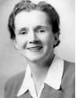  1907-1964 | Rachel Carson was an American scientist who studied the ocean and the environment.  In her book, 'The Sea Around Us', Rachel Carson described the habitats of the ocean.
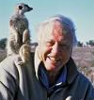  David Attenborough Born in 1926 | David Attenborough is a natural history TV presenter and is famous for introducing millions of people to the world’s animal and plants.  He has a degree in Natural Sciences from Cambridge University.

Scientific skills and enquiry (Year 1 and 2)

- asking simple questions and recognising that they can be answered in different ways
- observing closely, using simple equipment
- performing simple tests
- identifying and classifying
- using their observations and ideas to suggest answers to questions
- gathering and recording data to help in answering questions

