

Creech St Michael Primary School
Subject:  Biology | Animals and Humans- digestive system, teeth and food chains | Year  3 / 4

Background understanding (what I should already know)…
- notice that animals, including humans, have offspring which grow into adults
- find out about and describe the basic needs of animals, including humans, for survival (water, food and air)
- describe the importance for humans of exercise, eating the right amounts of different types of food, and hygiene
What I will know by the end of the unit…
Describe the simple functions of the basic parts of the digestive system in humans | 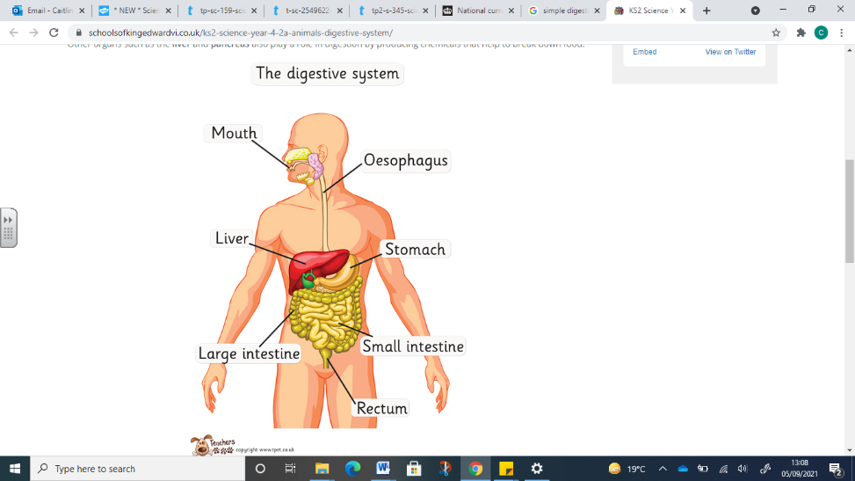
Teeth: the teeth of an animal are designed to eat different foods depending on the diet of the animal | 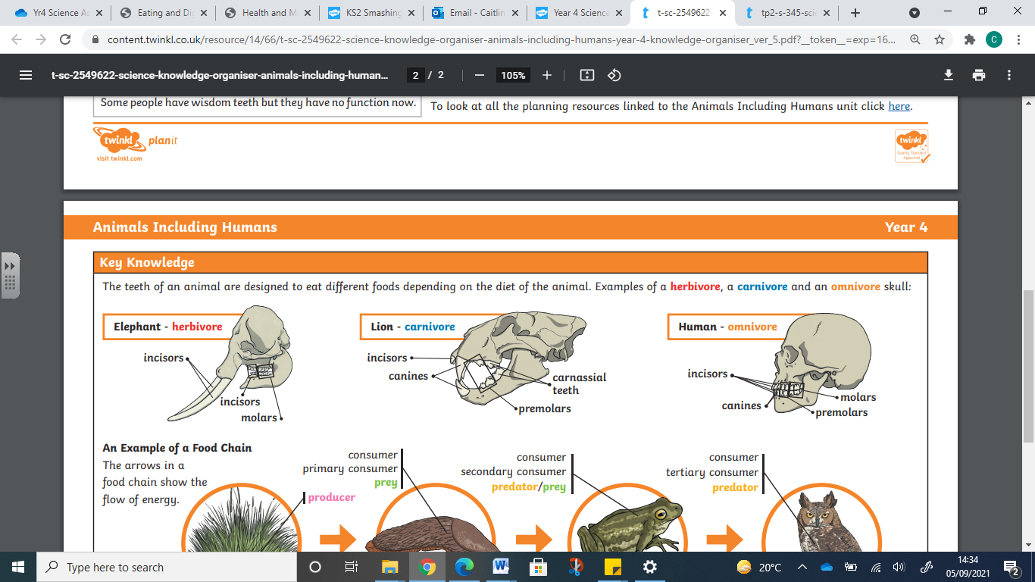
Teeth: identify the different types of teeth in humans and their simple functions | 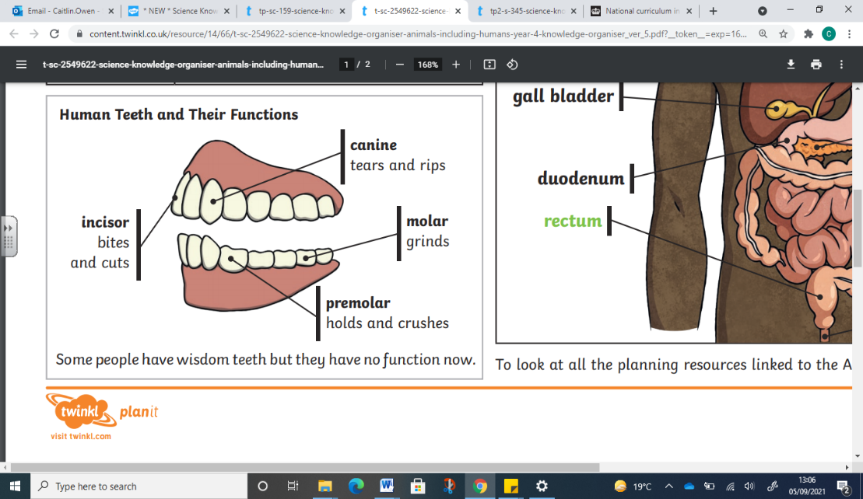
Food chains:  Construct & interpret a variety of food chains identifying produces, predators and prey. | 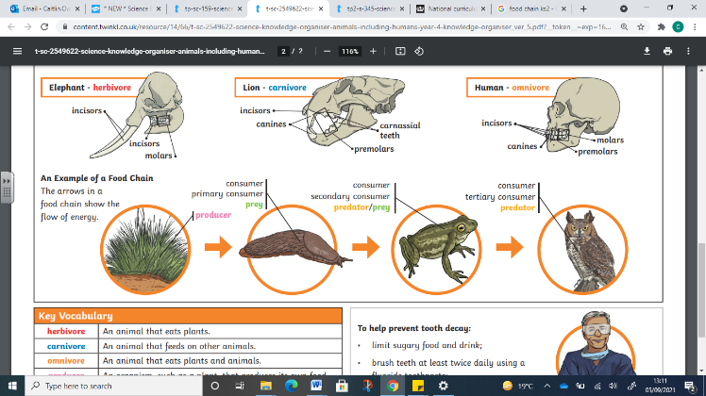
What: (key vocab)
Healthy | In a good physical and mental condition
Nutrients | Substances that living things need to stay alive and healthy
Energy | Strength to be able to move and grow
Digest | Break down food so it can be used by the body.
Oesophagus | A muscular tube which moves food from the mouth to the stomach.
Stomach | An organ in the digestive system where food is broken down with stomach acid and by being churned around.
Small intestine | Part of the intestine where nutrients are absorbed into the body.
Large intestine | Part of the intestine where water is absorbed from remaining waste food. Faeces are formed in the large intestine
Herbivore | An animal that eats plants.
Omnivore | An animal that eats plants and animals.
Carnivore | An animal that feeds on other animals.
Prey | An animal that gets hunted and eaten by another animal.
Predator | An animal that hunts and eats other animals
Producers | An organism, such as a plant, that produces its own food.
Consumer | Consumers are organisms that feed on plants or other animals for energy.
Canines | Teeth that tears and rips
Molars | Teeth that grind
Premolar | Teeth that hold and crushes
Incisor | Teeth that bites and cuts
Scientific skills and enquiry (Year 3/4)
- Ask relevant questions and use different types of scientific enquiries to answer them.
- Set up simple practical enquiries, comparative and fair tests.
- Make systematic and careful observations and, where appropriate, take accurate measurements using standard units, using a range of equipment, including thermometers and data loggers.
- Record findings using simple scientific language, drawings, labelled diagrams, keys, bar charts and tables.
- Gather, record, classify and present data in a variety of ways to help in answering questions.
- Identify differences, similarities or changes related to simple scientific ideas and processes.
- Report on findings from enquiries including oral and written explanations, displays or presentations of results and conclusions.
- Use straightforward scientific evidence to answer questions or to support their findings.
- Use results to draw simple conclusions, make predictions for new values, suggest improvements and raise further questions.

Possible Scientific Enquiry Questions…
Observing over time | What would happen to your teeth without brushing them? Observe an egg shell (the enamel of your teeth) left in squash or fizzy drinks.
Pattern seeking | What happens to health when living things have a good or a poor intake of nutrients?
Identifying, classifying and grouping | Can you identify which animals are vertebrates and which are invertebrates?

