

Creech St Michael Primary School
Science:  Physics | Electricity | Year  3 / 4

Background understanding (what I should already know)…
- Electricity is a form of energy that can be carried by wires and is used for heating and lighting, and to provide power for devices.
- Sources of light and sound may need electricity to work.
What I will know by the end of the unit…
Identify common appliances that run on electricity | 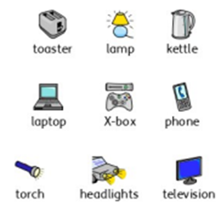
Construct a simple series electrical circuit, identifying and naming its basic parts, including cells, wires, bulbs, switches and buzzers | 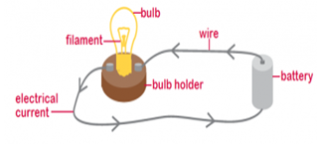  .
Identify whether or not a lamp will light in a simple series circuit, based on whether or not the lamp is part of a complete loop with a battery | 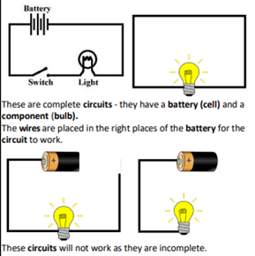
Recognise that a switch opens and closes a circuit and associate this with whether or not a lamp lights in a simple series circuit | 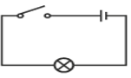  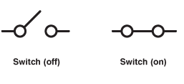
Recognise some common conductors and insulators, and associate metals with being good conductors | 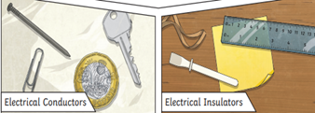
Key vocabulary
Appliance | A device or machine in your home used to do a job such as cleaning or cooking. Appliances are often electrical.
Battery | Small devices that provide power for electrical items such as torches. A battery is one or more cells, connected.
Bulb | The glass part of an electric lamp, which gives out light when electricity passes through it.
Buzzer | An electrical device that is used to make a buzzing sound
Cell | An electrical cell is a device used to generate electricity, or to make chemical reactions by applying electricity.
Circuit | A complete route which an electric current can flow around
Component | The parts that something is made of
Conductor | A substance that heat or electricity can pass through or along
Current | A flow of electricity through a wire or circuit
Device | An object that has been invented for a particular purpose
Electricity | A form of energy that can be carried by wires and is used for heating and lighting, and to provide power for devices
Energy | The power from sources such as electricity that makes machines work or provides heat
Fuel | A substance such as coal, oil, or petrol that is burned to provide heat or power
Generate | cause it to begin and develop
Insulator | A non-conductor of electricity or heat
Mains | Where the supply of water, electricity, or How does a gas enters a building
Motor | A device that uses electricity or fuel to produce movement
Power | Power is energy, especially electricity, that is obtained in large quantities from a fuel source and used to operate lights, heating, and machinery
Source | Where something comes from
Switch | A small control for an electrical device which you use to turn the device on or off
Wires | A long thin piece of metal that is used to fasten things or to carry electric current

Possible Scientific Enquiry Questions…
Observing Patterns | - Notice that the bulbs get brighter if more cells are added that metals tend to be conductors of electricity, and that some materials can and some cannot be used to connect across a gap in a circuit.
Identifying, classifying and grouping | - Investigate and sort which materials are electrical conductors and which are insulators.  - Transfer results from tables to a Venn diagram containing 2 intersecting sets ('electrical conductors' and 'made of metal') and try to identify a relationship.
Who: (famous people)
Thomas Alva Edison  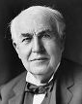  1847-1931 | Edison was a famous American inventor.  He’s best known for inventing domestic lightbulbs for use in houses, and the electric power system that allows them to work. He invented over 1000 successful inventions in his lifetime.
James Watt  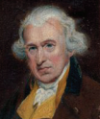  1736-1819 | Watt was born in Scotland. While working as an instrument maker at the University of Glasgow, Watt became interested in the technology of steam engines. He’s known as an inventor, mechanical engineer, and chemist who created the Watt steam engine in 1781, which was fundamental to the changes brought by the Industrial Revolution.
Nikola Tesla  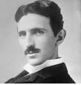  1856–1943 | Tesla was a Serbian inventor, electrical engineer, mechanical engineer, and physicist. Tesla was best known for his part in the design of the modern alternating current (AC) electricity supply system. His most famous invention was an electric motor that could run well on AC power

Circuit Symbols and Diagrams
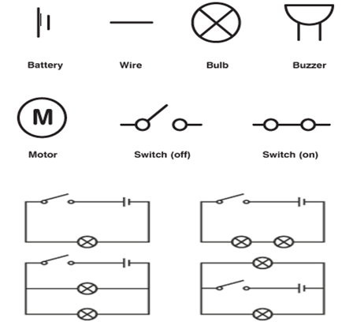

Scientific skills and enquiry (Year 3 and 4)

- Ask relevant questions and use different types of scientific enquiries to answer them.
- Set up simple practical enquiries, comparative and fair tests.
- Make systematic and careful observations and, where appropriate, take accurate measurements using standard units, using a range of equipment, including thermometers and data loggers.
- Record findings using simple scientific language, drawings, labelled diagrams, keys, bar charts and tables.
- Gather, record, classify and present data in a variety of ways to help in answering questions.
- Identify differences, similarities or changes related to simple scientific ideas and processes.
- Report on findings from enquiries including oral and written explanations, displays or presentations of results and conclusions.
- Use straightforward scientific evidence to answer questions or to support their findings.
- Use results to draw simple conclusions, make predictions for new values, suggest improvements and raise further questions.

