

Creech St Michael Primary School
Subject:  Biology | Living Things – Habitats and Classification | Year 3/4

Background understanding (what I should already know)…
- explore and compare the differences between things that are living, dead, and things that have never been alive
- identify that most living things live in habitats to which they are suited and describe how different habitats provide for the basic needs of different kinds of animals and plants, and how they depend on each other
- identify and name a variety of plants and animals in their habitats, including microhabitats
- describe how animals obtain their food from plants and other animals, using the idea of a simple food chain, and identify and name different sources of food
What: (key vocab)
Amphibian | Amphibians are vertebrate animals (have a backbone)
Characteristics | Characteristics are the distinguishing features or quality of something
Classify | Grouping things into categories
Endangered | A plant or animal where there are not many of their species left.
Environment | An environment contains many habitats and these include areas where there are living and non-living things.
Extinct | When a species has no more members alive on the planet, it is extinct.
Habitat | The specific area or place in which particular animals or plants may live.
Invertebrates | Animals without a backbone.
Mammal | Mammals include humans and all other animals that are warm-blooded vertebrates (vertebrates have backbones) with hair.
Organism | This is another word that can be used to mean ‘living things’.
Vertebrates | Animals with a backbone.
What I will know by the end of the unit…
Linnaeus Classification System | The system for classifying plants and animals and the system for naming all living things.  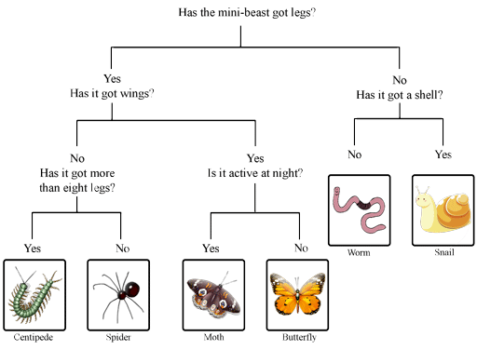
Animals can be grouped in lots of different ways based upon their characteristics. | 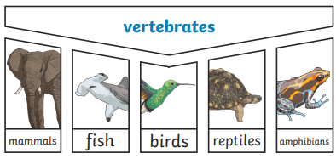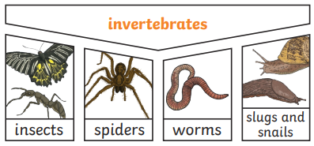
Classify plants according to their characteristics | 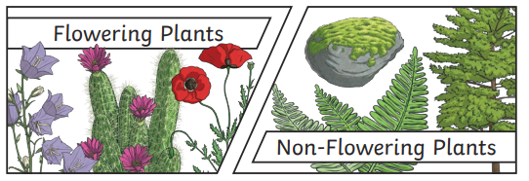

Possible Scientific Enquiry Questions…
Fair testing | Do all flowers have the same number of petals?
Identifying, classifying and grouping | Can you group a selection of livings things?  Why is your invertebrate a member of the …. group? Why could it not fit within a different group?

Who: (famous people)

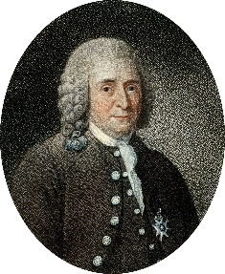  Carl Linnaeus  1707 - 1778 | One of the first scientists to create a classification system.
Working Scientifically

- asking relevant questions and using different types of scientific enquiries to answer them
- setting up simple practical enquiries, comparative and fair tests
- making systematic and careful observations and, where appropriate, taking accurate measurements using standard units, using a range of equipment, including thermometers and data loggers
- gathering, recording, classifying and presenting data in a variety of ways to help in answering questions
- recording findings using simple scientific language, drawings, labelled diagrams, keys, bar charts, and tables
- reporting on findings from enquiries, including oral and written explanations, displays or presentations of results and conclusions
- using results to draw simple conclusions, make predictions for new values, suggest improvements and raise further questions
- identifying differences, similarities or changes related to simple scientific ideas and processes
- using straightforward scientific evidence to answer questions or to support their findings

