

Creech St Michael Primary School
Science:  Physics | Electricity | Year  5/6

Background understanding (what I should already know)…
- Electricity is a form of energy that can be carried by wires and is used for heating and lighting, and to provide power for devices.
- Sources of light and sound may need electricity to work.
- A simple circuit contains various components including; a cell, wire, bulb, switch and buzzer.
- The symbols in a circuit will tell you if the circuit is on or off
- Recognise some common conductors (associate metals as good conductors) and insulators.
What I will know by the end of the unit…
How to change the brightness of a bulb or the speed of a buzzer in a circuit. | 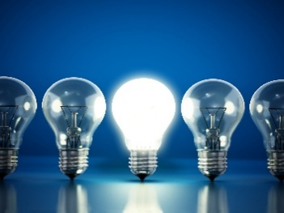
Recognise and use the conventional symbols for drawing a circuit. | . 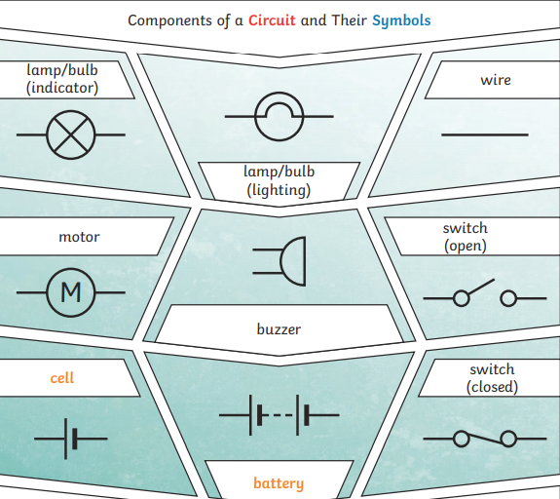
To know how the thickness of the wire affects the brightness of a bulb or the speed of a motor. | 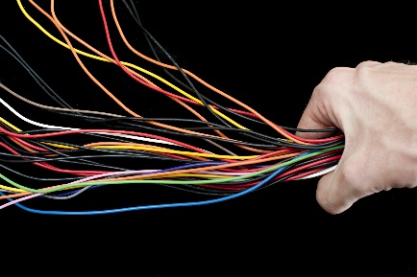
Key vocabulary
Amps | How electric current is measured
Battery | Small devices that provide power for electrical items such as torches. A battery is one or more cells, connected.
Bulb | The glass part of an electric lamp, which gives out light when electricity passes through it.
Buzzer | An electrical device that is used to make a buzzing sound
Cell | An electrical cell is a device used to generate electricity, or to make chemical reactions by applying electricity.
Circuit | A complete route which an electric current can flow around
Component | The parts that something is made of
Conductor | A substance that heat or electricity can pass through or along
Current | A flow of electricity through a wire or circuit
Device | An object that has been invented for a particular purpose
Electricity | A form of energy that can be carried by wires and is used for heating and lighting, and to provide power for devices
Electrons | Very small particles that travel around an electrical circuit.
Generate | cause it to begin and develop
Insulator | A non-conductor of electricity or heat
Mains | Where the supply of water, electricity, or How does a gas enters a building
Motor | A device that uses electricity or fuel to produce movement
Resistance | The difficulty that the electric current has when flowing around a circuit.
Switch | A small control for an electrical device which you use to turn the device on or off
Voltage | The force that makes the electric current move through the wires. The greater the voltage, the more current will flow.
Wires | A long thin piece of metal that is used to fasten things or to carry electric current

Who: (famous people)
Thomas Alva Edison  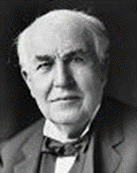  1847-1931 | James Watt  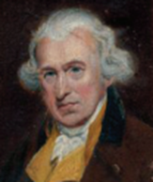  1736-1819 | Nikola Tesla  1856–1943  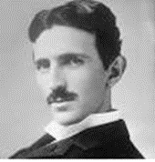
Edison was a famous American inventor. He’s best known for inventing domestic lightbulbs for use in houses, and the electric power system that allows them to work. He invented over 1000 successful inventions in his lifetime. | Watt was born in Scotland. While working as an instrument maker at the University of Glasgow, Watt became interested in the technology of steam engines. He’s known as an inventor, mechanical engineer, and chemist who created the Watt steam engine in 1781, which was fundamental to the changes brought by the Industrial Revolution. | Tesla was a Serbian inventor, electrical engineer, mechanical engineer, and physicist. Tesla was best known for his part in the design of the modern alternating current (AC) electricity supply system. His most famous invention was an electric motor that could run well on AC power

Possible Scientific Enquiry Questions…
Identifying, classifying and grouping | Can you group these materials into conductors and insulators?
Fair testing | How does the thickness of the wire affect the brightness of a bulb?
Scientific skills and enquiry (Year 5 and 6)

Planning different types of scientific enquiries to answer questions, including recognising and controlling variables where necessary

Taking measurements, using a range of scientific equipment, with increasing accuracy and precision, taking repeat readings when appropriate.

Recording data and results of increasing complexity using scientific diagrams and labels, classification keys, tables, scatter graphs, bar and line graphs.

Using test results to make predictions to set up further comparative and fair tests

Reporting and presenting findings from enquiries, including conclusions, causal relationships and explanations of and degree of trust in results, in oral and written forms such as displays and other presentations

Identifying scientific evidence that has been used to support or refute ideas or arguments.

