

Creech St Michael Primary School
Science:  Biology | Evolution | Year  5 / 6

Background understanding (what I should already know)…
- Compare and group together different kinds of rocks on the basis of their appearance and simple physical properties
- Describe in simple terms how fossils are formed when things that have lived are trapped within rock
- Recognise that soils are made from rocks and organic matter
What I will know by the end of the unit…
What was Darwin’s  Theory of Evolution? | The theory of evolution by natural selection (first formulated in Darwin's book "On the Origin of Species" in 1859) is the process by which organisms change over time. These changes occur due to changes in inheritable physical or behavioural traits.  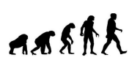
What is inheritance? | Inheritance refers to the characteristic traits that are genetically passed to offspring from their parents e.g. hair colour, eye colour, height etc. Darwin refers to this as natural selection when the strongest traits survive over generations.  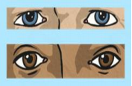
What are fossils and why are they important? | Fossils provide information about living things from the past. Fossils inform us about animals and plants that used to inhabit the Earth. Fossils are the impressions of the remains of prehistoric animals or plants embedded in rock and preserved in petrified form.  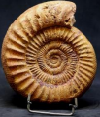
Living things have changed over time (adaptation) | Animals change over time and adapt to the surroundings in which they live. Darwin observed that there were many forms of finches with different beak sizes and shapes. Once he considered the food sources of each finch, he noted the reason for these adaptations.  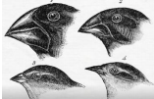
Key vocabulary
Evolution | The process by which different kinds of living organisms are believed to have developed from earlier forms during the history of the earth
Inherit | Derive (a quality, characteristic, or predisposition) genetically from one's parents or ancestors
Adaptation | The process of change by which an organism or species becomes better suited to its environment
Fossil | The remains or impression of a prehistoric plant or animal embedded in rock and preserved in petrified form
Organism | an individual animal, plant, or single-celled life form
Naturalist | An expert in or student of natural history
Geology | The science which deals with the physical structure and substance of the earth, their history, and the processes which act on them
Geologist | An expert in or student of geology
Biology | The study of living organisms
Biologist | An expert in or student of biology
Palaeontology | the branch of science concerned with fossil animals and plants
Palaeontologist | an expert in or student of palaeontology
Marine | Relating to or found in the sea
Theory | A system of ideas intended to explain something population the inhabitants of
Population | The inhabitants of a particular place e.g. a community of animals, plants, or humans
Successive | Following one another or following others
Generation | A set of members of a family regarded as a single step or stage in descent

Scientific skills and enquiry (Year 5 and 6)

• Plan different types of scientific enquiries to answer questions, including recognising and controlling variables where necessary.

• Take measurements, using a range of scientific equipment, with increasing accuracy and precision, taking repeat readings when appropriate.

• Record data and results of increasing complexity using scientific diagrams and labels, classification keys, tables, scatter graphs, bar and line graphs.

• Identify scientific evidence that used to support or refute ideas or arguments.

• Report and present findings from enquiries, including conclusions, causal relationships and explanations of and degree of trust in results, in oral and written forms such as displays and other presentations.

• Use test results to make predictions to set up further comparative and fair tests.
Who: (famous people)
Charles Darwin  Charles Robert Darwin (12 February 1809 – 19 April 1882) was an English born evolutionary biologist, naturalist and geologist who was best known for his contributions to the science of evolution. He first formulated his theory in his book "On the Origin of Species" in 1859 | Charles Darwin  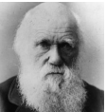
Alfred Wallace  Alfred Russel Wallace was born in Wales in 1823. He is considered as a naturalist and a geographer. Wallace is best known for is his work on the theory of natural selection. In 1858, he sent Darwin a letter outlining his ideas about evolution. The two collaborated (worked together) on a scientific paper, discussing their evidence for natural selection and evolution. | 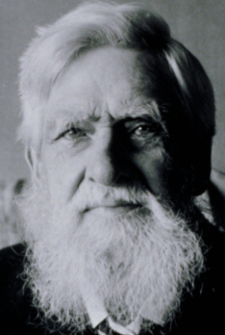
Mary Anning  (21 May 1799 – 9 March 1847) was an English fossil collector, dealer, and palaeontologist who became known around the world for important finds she made in Jurassic marine fossil beds in the cliffs along the English Channel at Lyme Regis in the county of Dorset in Southwest England. | Mary Anning  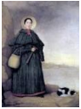

Living Things |  | Habitat |  | Adaptive Traits
Polar Bear |  | Artic | 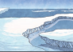 | Its white fur enables it to camouflage in the snow.
Camel | 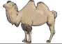 | Desert |  | It has wide feet to make it easier to walk in the sand.
Cactus |  | Desert | 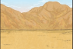 | It stores water in its stem.
Toucan |  | Rain Forest | 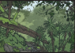 | Its narrow tongue allows it to eat small fruit and insects.

