

Creech St Michael Primary School
Subject:  Biology | Human Circulatory System | Year 5/6

Background understanding (what I should already know)…
Animals including Humans:
- Describe the importance for humans of exercise, eating the right amounts of different types of food, and hygiene.
- Identify that animals, including humans, need the right types and amount of nutrition, and that they cannot make their own food; they get nutrition from what they eat.
- Describe the simple functions of the basic parts of the digestive system in humans.
What I will know by the end of the unit…
Balanced Diet | A balanced diet incudes a variety of food types (carbohydrates. protein, diary, fruit and vegetables and fats).  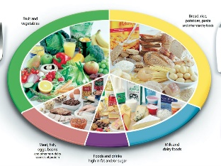
Circulatory system | The circulatory system transports blood around the body. Blood contains the nutrients, water and oxygen your body needs to survive and can take them to all the places in the body they needed.  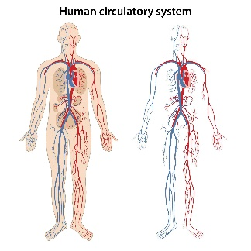
Heart Rate & Pulse | Heart rate is the number of times the heart beats each minute. Daily activities can change how fast or slow the rate fluctuates.  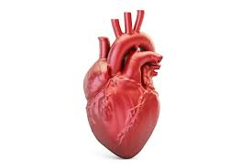
What: (key vocab)
Arteries | Blood vessels that carry blood away from the heart.
Balanced Diet | A diet consisting of a variety of different types of food and providing adequate amounts of the nutrients necessary for good health.
Blood | Fluid that transports oxygen and nutrients to the cells and carries away carbon dioxide and other waste products.
Carbon Dioxide | A gas without colour or odour that is made up of carbon and oxygen.
Circulatory system | The system that circulates blood through the body.
Digestive System | Digestive system consists of the parts of the body that work together to turn food and liquids into the building blocks and fuel that the body needs.
Food groups | One of the main groups that foods belong to.
Heart | It is a muscle which functions as a really powerful pump.
Lungs | Lungs are air sacs, or body parts, used for breathing. They are part of the body's respiratory system.
Oxygen | is a colourless, odourless, tasteless gas essential to living organisms, being taken up by animals, which convert it to carbon dioxide.
Pulse | Your beating heart creates a pulse.
Veins | Blood vessels that carry blood to the heart.

Who: (famous people)

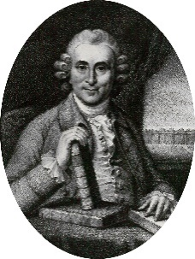  James Lind  1716 - 1794 | Lind conducted the world’s first known clinical trial. He explored whether citrus fruit cured scurvy.
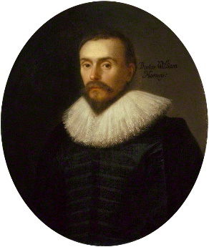  William Harvey  1578 – 1657 | He is the first known physician to describe completely, and in detail, the systemic circulation and properties of blood being pumped to the brain and the rest of the body by the heart.
Scientific skills and enquiry (Year 5 and 6)
- Identifying scientific evidence that has been used to support or refute ideas or arguments.
- Planning different types of scientific enquiries to answer questions, including recognising and controlling variables where necessary.
- Taking measurements, using a range of scientific equipment, with increasing accuracy and precision, taking repeat readings when appropriate.
- Recording data and results of increasing complexity using scientific diagrams and labels, classification keys, tables, scatter graphs, bar and line graphs.
- Using test results to make predictions to set up further comparative and fair tests.
- Reporting and presenting findings from enquiries, including conclusions, causal relationships and explanations of and degree of trust in results, in oral and written forms such as displays and other presentations.

Possible Scientific Enquiry Questions…
Observing over time | How long does it take for a pulse to return to a resting rate after exercise?
Pattern seeking | Is there a pattern between what we eat for breakfast and how fast we can run?
Identifying, classifying and grouping | Can you group these foods into different food groups?
Fair testing | Does varying types of exercise impact a heart rate differently?

