

Creech St Michael Primary School
Subject:  Physics | Light | Year 5/6

Background understanding (what I should already know)…
- I understand that dark is the absence of light.
- I understand how surfaces reflect light.
- I can recognise that a mirror appears to reverse an image.
- I can identify opaque, translucent and transparent objects.
- I know how shadows change size.
What: (key vocab)
Absorb | Light absorption is a process by which light is absorbed and converted into energy
Light ray | Light rays are imaginary lines that represent the motion of waves of visible light
Light source | A light source generates light using another form of energy such as heat or electricity.
Opaque | When all light is absorbed or reflected; no image can be seen
Periscope | A periscope is a simple device that enables people to see over walls or round corners. Rays of light hitting the mirror of the periscope are reflected twice
Rainbow | An arch in the sky formed by the refraction of sunlight through raindrops
Reflection | When light bounces off of an object
Refraction | Light travels and bounces off surfaces into our eyes. When light travels from air through water, glass or a different surface, it gets bent. This bending is called refraction.
Shadow | A shape produced by light being blocked by an opaque object
Translucent | A substance that allows some light to pass through it
Transparent | A substance that allows most of the light to pass through it
What I will know by the end of the unit…
Formation of Shadows | Light will travel away from a light source until it meets an object; when something blocks light travelling from a source, a shadow is made.  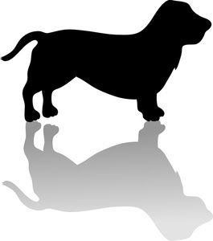
Understanding of how an eye works | The eye is a ball with a hole at the front, the pupil, which lets in light. Inside the eye is a lens which focuses the light onto a surface at the back of the eyeball. This surface is called the retina and is made up of special cells which detect light and send messages to our brain, allowing us to see.  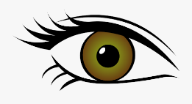
Reflection and Refraction | Reflection  When light bounces off of an object  Refraction  When light travels from air through water, glass or a different surface, it gets bent. This bending is called refraction.  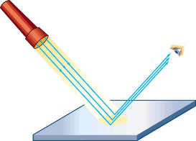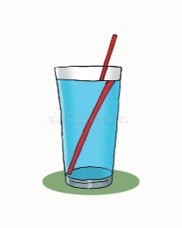

Who: (famous people)

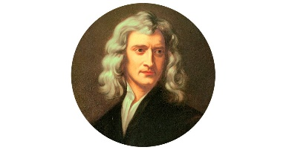  Isaac Newton  1643 – 1727 | Newton discovered that white light is a mixture of seven different colours and can be split into these colours
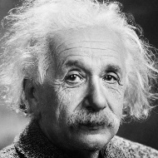  Albert Einstein  1879 - 1955 | Einstein's discovered that that light always travels at a constant speed.
Scientific skills and enquiry (Year 5 and 6)
- Identifying scientific evidence that has been used to support or refute ideas or arguments.
- Planning different types of scientific enquiries to answer questions, including recognising and controlling variables where necessary.
- Taking measurements, using a range of scientific equipment, with increasing accuracy and precision, taking repeat readings when appropriate.
- Recording data and results of increasing complexity using scientific diagrams and labels, classification keys, tables, scatter graphs, bar and line graphs.
- Using test results to make predictions to set up further comparative and fair tests.
- Reporting and presenting findings from enquiries, including conclusions, causal relationships and explanations of and degree of trust in results, in oral and written forms such as displays and other presentations.

Possible Scientific Enquiry Questions…
Observing over time | How does the size of a shadow alter over the course of a day?
Pattern seeking | Is there a pattern between shadow visibility and the weather?

