

Creech St Michael Primary School
Science | Animals Including Humans – Growth and Survival | Year  2

Background understanding (what I should already know)…
- Identify and name a variety of common animals including, fish, amphibians, reptiles, birds and mammals
- Identify and name a variety of common animals that are carnivores, herbivores and omnivores
- Describe and compare the structure of a variety of common animals (fish, amphibians, reptiles, birds and mammals including pets)
- Identify, name, draw and label the basic parts of the human body and say which part of the body is associated with each sense.
What I will know by the end of the unit…
Notice that animals, including humans, have offspring which grow into adults | 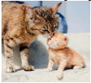  Some animals give birth to live young  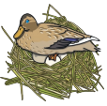  Other animals lay eggs  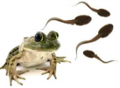  Some animal babies do not look the same as adults.
Find out about and describe the basic needs of animals, including humans, for survival (water, food and air) | To stay alive, animals including humans need food, water and air.      
Describe the importance for humans of exercise, eating the right amounts of different types of food, and hygiene | 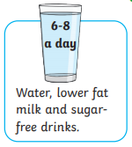  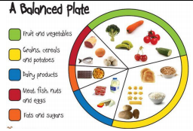  To grow into a healthy adult, we must eat the right types of food in the right amount and exercise!
Key Vocabulary
adult | A fully grown animal or plant
baby | A very young child or animal
develop | To grow bigger and become stronger.
diet | The food and water that humans and animals need.
exercise | A physical activity that keeps your body fit.
hygiene | 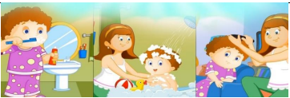  To stop illness, infections and diseases spreading, we must be hygienic and keep ourselves clean.
life cycle | 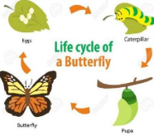  The changes living things go through to become an adult.
live young | Offspring that has not hatched from an egg.
nutrition | Food needed to live
offspring | The child of a human or animal
pulse | The beating of the heart that you can feel in your neck and wrist.
reproduce | When living things make a new living thing of the same kind.
Survival | Continue to exist
young | Offspring that has not reached adulthood

Who: (famous people)
Louis Pasteur    1822-1895 | Pasteur was a French scientist who discovered that germs are living things that can spread by touch or through the air. He discovered pasteurisation and vaccines for deadly diseases.
Elizabeth Garrett- Anderson    1836-1916 | Elizabeth was the first English woman to qualify as a doctor. She qualified in 1865.

Scientific skills and enquiry (Year 1 and 2)

- asking simple questions and recognising that they can be answered in different ways
- observing closely, using simple equipment
- performing simple tests
- identifying and classifying
- using their observations and ideas to suggest answers to questions
- gathering and recording data to help in answering questions

Possible Scientific Enquiry Questions…
Observing over time | - Record a food-diary and evaluate their diet  - Investigate what happens to their bodies when they try different forms of exercise.
Pattern seeking | - Carry out a class survey to find out how much water they drink each day.  - Collect and present data about favourite foods  - Investigate relationships between age of children and size of body parts (hands or feet). Measure different ages across the school using non-standard units.
Identifying, classifying and grouping | - Free-sorting food into groups and explaining how/why they chose those groups  - Sort food pictures into a food groups  - Sort food groups into a food pyramid
Gathering and recording data to help in answering questions | - construct simple pictograms, tally charts, block diagrams and tables linked to class surveys

