

Creech St Michael Primary School
Science: | Plants | Year  2

Background understanding (what I should already know)…
- Identify and name a variety of common wild and garden plants, including deciduous and evergreen trees
- Identify and describe the basic structure of a variety of common flowering plants, including trees
What I will know by the end of the unit…
I can observe and describe how a plant grows and what happens when it dies | 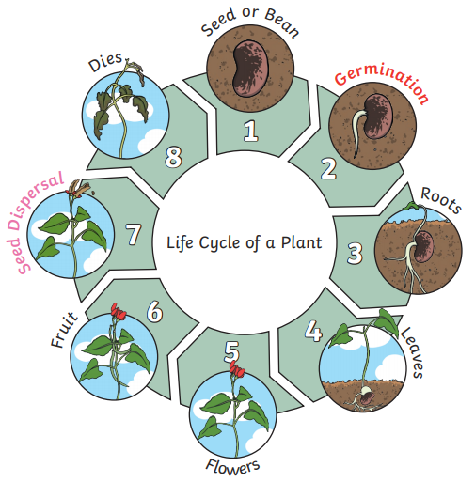
I can observe and describe how seeds and bulbs grow into mature pIants.  I can find out and describe how plants need water, sunlight and a suitable temperature to grow and stay healthy. | 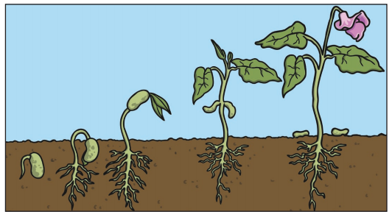  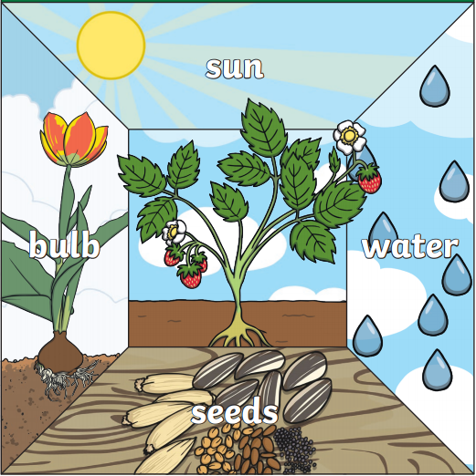
Key vocabulary
Germination
Nutrition | Food or nourishment. Plants use sunlight to make their own food in their leaves.
Sprout | When a plant sprouts, it grows new leaves.
Shoot | A shoot grows upwards from a seed or plant to find sunlight.
Seed dispersal | When the seed moves away from the parent plant. They can be moved by the wind or animals.
Sunlight | All plants need light from the sun to grow well. Some plants needs lots of sunlight and some need less sunlight.
Temperature | Temperature is how warm or how cold somewhere is. Some plants like warmer temperatures and some like cooler temperatures.
Water | All plants need water to grow. Without sunlight, seeds will not germinate.

Possible Scientific Enquiry Questions…
Observing over time | What happens to the seed/plant each day, each week, each month?
Pattern seeking | Do all plants grow to the same height? Do they all grow in the same conditions?
Identifying, classifying and grouping | How can you sort and group these plants, flowers, trees?
Fair testing | Have we used the same amount of water? Have we planted the same number of seeds?
Scientific skills and enquiry (Year 1 and 2)

- asking simple questions and recognising that they can be answered in different ways
- observing closely, using simple equipment
- performing simple tests
- identifying and classifying
- using their observations and ideas to suggest answers to questions
- gathering and recording data to help in answering questions.

