

Creech St Michael Primary School
Science: | Uses of Everyday Materials | Year  2

Background understanding (what I should already know)…
- distinguish between an object and the material from which it is made.
- identify and name a variety of everyday materials, including wood, plastic, glass, metal, water, and rock.
- describe the simple physical properties of a variety of everyday materials.
- compare and group together a variety of everyday materials on the basis of their simple physical properties.
What I will know by the end of the unit…
I can identify and compare materials.  I know why materials are suitable for a specific use. | 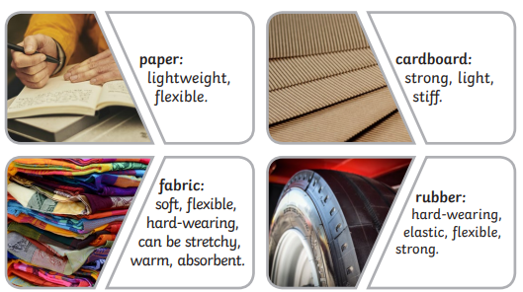  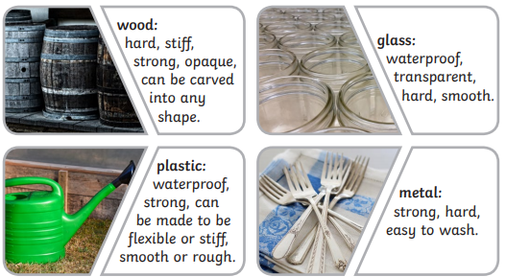
I know how some materials can be changed | 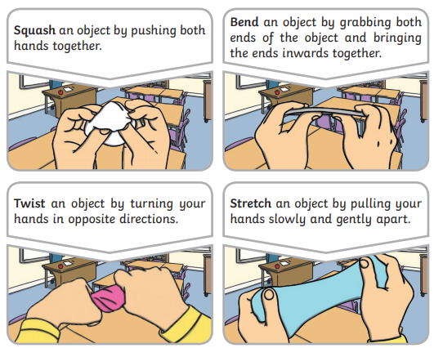
Key vocabulary
Absorbent | It soaks water up.
Flexible | It can bend without breaking.
Hardwearing | It can last a long time. It does not wear out quickly.
Lightweight | It is built lightly.
Materials | What an object is made from.
Opaque | You cannot see through it.
Properties | What a material is like (soft, stretchy)
Stiff | It does not bend easily and is strong.
Suitability | It is the right thing to use.
Transparent | It is see-through.
Waterproof | It keeps water out. It keeps it dry.

Who: (famous people)
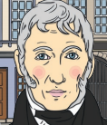 | John McAdam was a Scottish engineer who used new materials to build roads. He invented a process called ‘macadamisation’ which was used across the world.  
 | 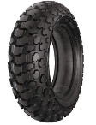  John Dunlop was a Scottish inventor who invented the air-filled rubber type in 1887. He first used rubber to make tyres for his son’s tricycle.
 | 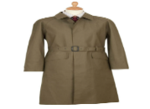  Charles Macintosh was a Scottish inventor who invented waterproof fabrics in 1818. The Macintosh raincoat was created in 1824.

Possible Scientific Enquiry Questions…
Observing over time | What happens to the water when you add drops to the material?
Pattern seeking | Are all shiny materials waterproof?
Identifying, classifying and grouping | How can you sort and group these materials?
Fair testing | Have we used the same amount of water? Is the material the same size?
Scientific skills and enquiry (Year 1 and 2)

- asking simple questions and recognising that they can be answered in different ways
- observing closely, using simple equipment
- performing simple tests
- identifying and classifying
- using their observations and ideas to suggest answers to questions
- gathering and recording data to help in answering questions.

