

Creech St Michael Primary School
Science:  Chemistry | States of Matter | Year  3 / 4

Background understanding (what I should already know)…
- Identify and compare the suitability of a variety of everyday materials, including wood, metal, plastic, glass, brick, rock, paper and cardboard for particular uses
- Find out how the shapes of solid objects made from some materials can be changed by squashing, bending, twisting and stretching
What I will know by the end of the unit…
Changing states of Matter | Can change from one state to another if it is heated or cooled – solid, liquid and gas  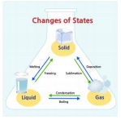
The water cycle | The water cycle is a complete journey that water makes, from one place to another and from one state to another.  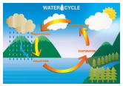
Solids hold their shape | Solid particles are tightly packed together.  Solids can hold their shapes (for example, water in the form of ice).  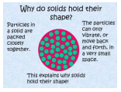
Liquid | A liquid like water forms a pool. It flows or runs but it can’t be stretched or squeezed. Liquids form the shape of whatever container they are kept in (Swimming pool; cup; tube; straw…)  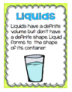
Gas will escape  from an  unsealed  container | 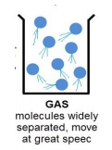  A gas can flow, expand and be squeezed; if it is in an unsealed container it escapes.
Key vocabulary
Boiling point | The temperature at which a liquid boils and turns to vapour.
Bond | Joined securely to something else condensation turn a gas into a liquid.
Celsius | A scale of temperature on which water freezes at 0 degrees and boils at 100 degrees under standard conditions.
Condensation | Turn a gas into a liquid.
Evaporation | Turn a liquid into a gas.
Gas | A substance that will expand freely to fill a whole container and has no fixed shape or volume.
Irreversible | Not able to be undone or altered - a chemical change has occurred.
Liquid | A substance that flows freely but is of constant volume.
Matter | Makes up our planet and the whole universe. On Earth, all matter exists in one of three different states: solid, liquid or gas.
Melting point | The temperature at which a given solid will melt
Molecules | The very tiny particles that make matter
Precipitation | Liquid or solid particles that fall from a cloud as rain, sleet, hail or snow.
Reversible | Capable of being reversed so that the previous state is restored.
States of Matter | Materials can be one of three states: solids, liquids or gases. Some materials can change from one state to another and back again.
Thermometer | An instrument for measuring and indicating.
Transpiration | The exhalation of water vapour in plants
Water cycle | The cycle of processes by which water circulates between the Earth's oceans, atmosphere, and land.

Who: (famous people)
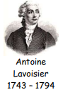 | Most noted for his discovery of the role oxygen plays in combustion. He recognized and named oxygen (1778) and hydrogen (1783).
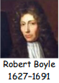 | Boyle discovered that the volume of a gas decreases with increasing pressure and vice versa—the famous Boyle's law
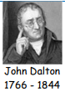 | In 1803, he proposed that matter is made up of atoms that are indivisible and indestructible.
Scientific skills and enquiry (Year 3 and 4)

- Ask relevant questions and use different types of scientific enquiries to answer them.
- Set up simple practical enquiries, comparative and fair tests.
- Make systematic and careful observations and, where appropriate, take accurate measurements using standard units, using a range of equipment, including thermometers and data loggers.
- Record findings using simple scientific language, drawings, labelled diagrams, keys, bar charts and tables.
- Gather, record, classify and present data in a variety of ways to help in answering questions.
- Identify differences, similarities or changes related to simple scientific ideas and processes.
- Report on findings from enquiries including oral and written explanations, displays or presentations of results and conclusions.
- Use straightforward scientific evidence to answer questions or to support their findings.
- Use results to draw simple conclusions, make predictions for new values, suggest improvements and raise further questions.
Possible Scientific Enquiry Questions…
Observing over time | How does the level of water in a glass change when left on a windowsill?
Pattern seeking | Is there a pattern in how long it takes different sized ice-lollies to melt?
Identifying, classifying and grouping | Can you group these materials into solids, liquids and gases?
Fair testing | How does the mass of a block of ice affect how long it takes to melt?

