

Creech St Michael Primary School
Science:  Biology | LIFE CYCLES IN PLANTS AND ANIMALS | Year  5 / 6

Background understanding (what I should already know)…
- Animals can be grouped into vertebrates (and then further into fish, reptiles, amphibians, birds and mammals) and invertebrates.
- Some examples of life cycles (including those of plant and humans)
- The processes of dispersal, fertilisation and germination. Reproduction is one of the seven life processes.
- Parts of a plant, their features and what their functions are
What I will know by the end of the unit…
Examples of Life Cycles | - Life cycles of mammals, birds, amphibians and insects – they have similarities and differences (eg, metamorphosis of amphibians and insects)
How plants reproduce | 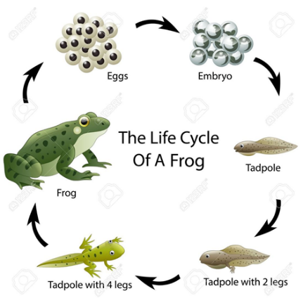  - Males gametes are found in pollen  - Female gametes are found in the ovules  - Pollination occurs when pollen from the anther is transferred to the stigma by bees and other insects  - Pollen travels down and meets the ovule  - When this happens, seeds are formed (fertilisation)  - Seeds are then dispersed so that germination can begin again.  - Some plants, such as daffodils and potatoes, can also produce offspring using asexual reproduction.  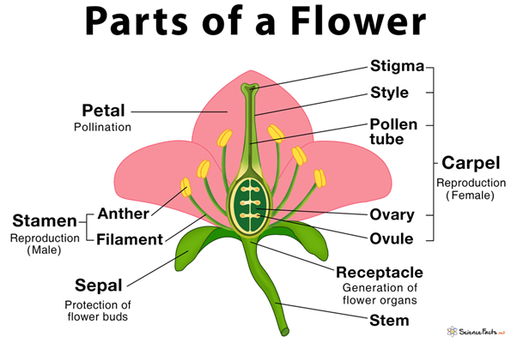
What reproduction is | - Reproduction is when an animal or plant produces one or more individuals similar to itself.  - Sexual reproduction requires two parents with male and female gametes (cells); it will produce offspring similar but not identical to the parent.  - Asexual reproduction will produce offspring identical to the parent and requires only one parent.
Key vocabulary
anther | The part of a stamen that produces and releases the pollen
bulb | A root shaped like an onion that grows into a flower or plant
cell | The smallest part of an animal or plant that is able to function independently
dispersed | Scattered, separated or spread through a large area
dissect | To carefully cut something up in order to examine it scientifically
embryo | An unborn animal or human being in the very early stages of development
fertilisation | Male and female gametes meet to form an embryo or seed
flower | The part of the plant which is often brightly coloured and grows at the end of a stem
flowering | Trees or plants which produce flowers
gamete | the name for two types of male and female cells that join together to make a new creature
germination | If a seed germinates or if it is germinated, it starts to grow
life cycle | The series of changes that a plant or animal pass through from the beginning of its life until its death
mature | When something matures, it is fully developed.
metamorphosis | a person or thing develops and changes into something completely different (eg a caterpillar to a butterfly)
ovary | a female organ which produces eggs
ovule | A small egg
petal | Thin, coloured or white parts which form part of the flower
plant | A living thing that grows in the earth and has a stem, leaves and roots
pollen | A fine powder produced by flowers. It fertilises other flowers of the same species so they produce seeds
pollination | To pollinate a plant or tree means to fertilise it with pollen. This is often done by insects
reproduction | When an animal or plant produces one or more individuals similar to itself
seed | The small, hard part from which a new plant grows
stigma | The top of the centre part of a flower which takes in pollen
structure | The way in which something is built or made

Who: (famous people)
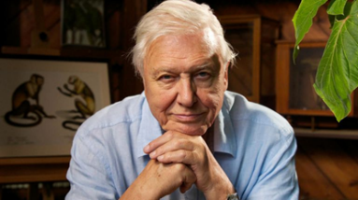  David Attenborough  (1926-) | Natural historian and English broadcaster, famous for his extensive knowledge and BBC TV programmes on the natural world. He is also renowned for encouraging people to get involved with nature and help tackle climate change.
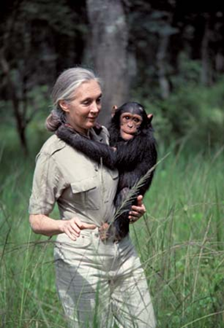  Jane Goodall  (1934-) | A well-known primatologist, humanitarian and animal rights campaigner, Jane Goodall is famous for her detailed studies of chimpanzees in Tanzania, observing how they interacted in family and social situations.
Scientific skills and enquiry (Year 5)

- planning different types of scientific enquiries to answer questions, including recognising and controlling variables where necessary
- taking measurements, using a range of scientific equipment, with increasing accuracy and precision, taking repeat readings when appropriate
- recording data and results of increasing complexity using scientific diagrams and labels, classification keys, tables, scatter graphs, bar and line graphs
- using test results to make predictions to set up further comparative and fair tests
- reporting and presenting findings from enquiries, including conclusions, causal relationships and explanations of and degree of trust in results, in oral and written forms such as displays and other presentations
- identifying scientific evidence that has been used to support or refute ideas or arguments.
Possible Scientific Enquiry Questions…
Observing and comparing over time | How do the life cycles or plants and animals in our local area compare with other plants and animals around the world (eg, in the rainforest, in the oceans, deserts or in prehistoric times)?
Pattern seeking | Are there reasons for the differences or similarities in the life cycles of plants and animals when compared with those of others around the world?  How do the gestation periods of other animals compare with that of humans?
Identifying, classifying and grouping | Can you grow a new plant from different parts of the parent plants (for example, seeds, stem, root cuttings, tubers, bulbs)?
Fair testing | How do different conditions affect plant growth?

