|  |  |  |
| --- | --- | --- |
| **Creech St Michael Primary School** | | |
| **Science:** | **Animals including Humans** | **Year 1** |

|  |  |
| --- | --- |
| **What I will know by the end of unit** | |
| **I can identify and name a variety of common animals**  **I can identify and name a variety of common UK mammals**  **I can identify and name a variety of common UK birds and reptiles**  **I can identify and name a variety of common UK fish and amphibians**  **I can identify and sort omnivores, herbivores and carnivores**  **I know how to take care of animals**  **I can identify, name and label body parts**  **I can explore what parts of our bodies we use for different activities**  **I can find out about my five senses** |  |

|  |  |
| --- | --- |
| **What: (key vocab)** | |
| **Amphibians** | Amphibians live in the water as babies and on land as they grow older. They have smooth, slimy skin. |
| **Birds** | All birds have a beak, two legs, feathers and wings. |
| **Fish** | Fish live and breathe under water. They have scaly skin, fins to help them swim and they breathe through gills |
| **Mammals** | Mammals are animals that breathe air, grow hair or fur and feed on their mother’s milk as a baby. |
| **Reptiles** | All reptiles breathe air. They have scales on their skin. |
| I Ate Nothing but Meat for 2 Weeks. Here&#39;s What It Was Like | Inc.com**Carnivores** | Animals that mostly eat other animals (meat) are carnivores |
| **Herbivores** | Animals that only eat plants are herbivores |
| **Omnivores** | Animals that eat both plants and other animals are omnivores. |
| **Touch** | Your skin gives you the sense of touch. You can tell if something is warm, cold, smooth or rough without even looking at it! |
| **Hearing** | Your ears let you listen to all the things around you. Your brain is able to tell what different sounds are |
| **Sight** | Your eyes let you see all the things around you |
| **Taste** | Your sense of taste comes from your tongue. You can tell if something tastes bitter or sweet. You might have some tastes you like and some you don’t. |
| **Smell** | You smell using your nose. Your nose can tell if things smell nice or not nice |

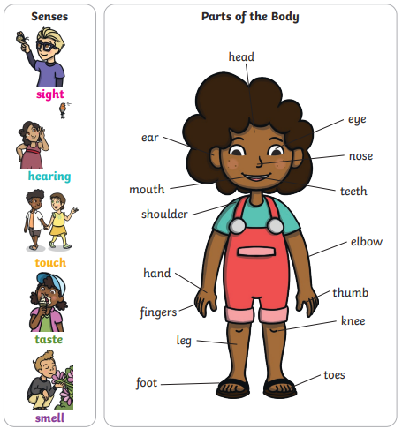

**Scientific skills and enquiry (Year 1)**

* asking simple questions and recognising that they can be answered in different ways
* observing closely, using simple equipment
* performing simple tests
* identifying and classifying
* using their observations and ideas to suggest answers to questions
* gathering and recording data to help in answering questions.