

Creech St Michael Primary School
Science: | Everyday Materials | Year 1
Scientific skills and enquiry (Year 1)
- asking simple questions and recognising that they can be answered in different ways
- observing closely, using simple equipment
- performing simple tests
- identifying and classifying
- using their observations and ideas to suggest answers to questions
- gathering and recording data to help in answering questions.
What: (key vocab)
object | A thing that can be used
material | What an object is made of
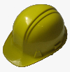  hard | Not easily broken or bent
  soft | Easy to cut, fold or change the shape of
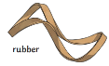  stretchy | Can be pulled to change length or width without breaking
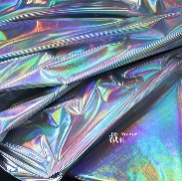  shiny | Reflects light easily
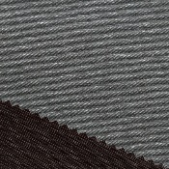  dull | Doesn’t reflect light. Not shiny
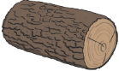  rough | Feels and looks uneven and bumpy
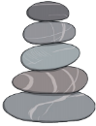  smooth | Has no lumps or bumps
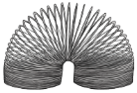  bendy | Can be folded easily
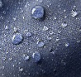  waterproof | Keeps water out – keeps things dry
absorbent | Will soak up liquid
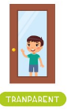  transparent | Transparent objects can be seen through
  opaque | Opaque objects can’t be seen through
What I will know by the end of unit
I can identify a variety of materials.  I can distinguish between an object and the material it is made of  I can describe materials according to their properties  I can describe why some materials suit certain objects better than others | 