|  |  |  |
| --- | --- | --- |
| **Creech St Michael Primary School** | | |
| **Science:** | **Plants** | **Year 1** |

|  |  |
| --- | --- |
| **What: (key vocab)** | |
| **Wild plants** | A wild plant seed grows where it falls. It doesn’t need to be planted or cared for as it grows. |
| **Garden plants** | Garden plants are plants that people choose to grow in their gardens. |
| **Weed** | Weeds are wild plants that grow in places where people don’t want them |
| **Deciduous** | A deciduous tree loses its leaves each year. |
| **Evergreen** | An evergreen tree keeps its green leaves all year round, even in the winter. |
| **Roots** | Roots take in water and nutrients from the soil and keep the plant in the ground. |
| **Stem** | The stem holds the plant up and carries the water and nutrients from the roots to the leaves and flowers. |
| **Leaves** | Leaves catch sunlight to help the plant to make its own food. |
| **Flowers** | Flowers attract insects and birds. |
| **Petals** | Petals are the colourful part of the flower. |
| **Fruit** | Fruit contains the plant’s seeds. Sometimes humans try to grow fruit without seeds because it’s easier to eat. |
| **Seeds** | Seeds grow into new plants. |
| **Bulb** | Bulbs grow into new plants |

|  |  |
| --- | --- |
| **What I will know by the end of unit** | |
| **I can identify what a plant is**  **I can identify a variety of garden plants**  **I can identify a variety of wild plants**  **I can identify and describe a range of trees**  **I can identify different parts of a plant**  **I can make observations of growing plants** |  |

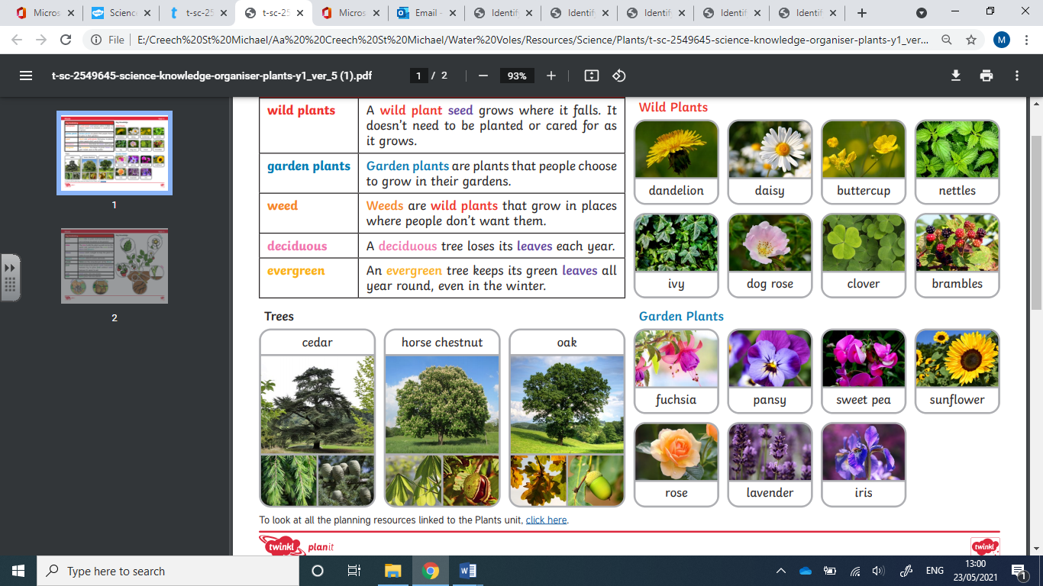

**Scientific skills and enquiry (Year 1)**

* asking simple questions and recognising that they can be answered in different ways
* observing closely, using simple equipment
* performing simple tests
* identifying and classifying
* using their observations and ideas to suggest answers to questions
* gathering and recording data to help in answering questions.