

Creech St Michael Primary School
Science:  Biology | Living Things and Habitats: Plants | Year  3 / 4

Background understanding (what I should already know)…
- Identify and name a variety of common wild and garden plants, including deciduous and evergreen trees.
- Identify and describe the basic structure of a variety of common flowering plants, including trees.
- Observe and describe how seeds and bulbs grow into mature plants.
- Find out and describe how plants need water, light and a suitable temperature to grow and stay healthy.
What I will know by the end of the unit…
How water moves through a plant. | - The roots absorb the water from the soil.  - The stem transports water to the leaves.  - Water evaporates from the leaves  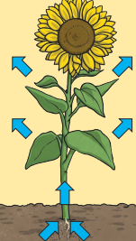  - This evaporation causes more water to be sucked up the stem.
Parts of a flowering plant | 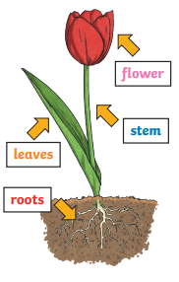
What does a plant need to grow? | - Water  - Light  - Nutrients from the soil  - Air  - Room to grow
Seed dispersal | 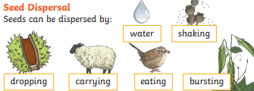
The life cycle of a flowering plant | 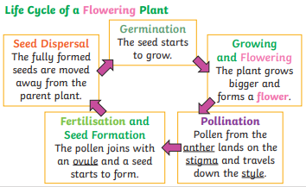
Key vocabulary
Carpel | The female parts of the flower. Made up of the stigma, style and ovary. The ovary contains the ovules, which are the part of the flower that gets fertilised and eventually becomes the new seed.
Evaporation | When a liquid turns into a gas.
Fertilisation | When parts of the flower have mixed in order to make seeds for new plants.
Flowers | These make seeds to grow into new plants. Their petals attract pollinators to the plant.
Germination | When a seed starts to grow.
Leaves | These make food for the plant using sunlight and carbon dioxide from the air.
Nutrients | These substances are needed by living things to grow and survive. Plants get nutrients from the soil and also make their own food in their leaves.
Petal | The brightly coloured part of the flower that attracts insects to pollinate the plant.
Pollination | When pollen (a fine powdery substance produced by a flowering plant) is moved from the male anther of a flower to the female stigma.
Pollinator | Animals or insects which carry pollen between plants. Examples include birds, bees and bats.
Roots | These anchor the plant into the ground and absorb water and nutrients from the soil.
Seed dispersal | A method of moving the seeds away from the parent plant so that the seeds have the best chance of survival.
Stem | This holds the plant up and carries water and nutrients from the soil to the leaves. A trunk is the stem of a tree.

Who? (Important People)
Sir Joseph Banks  1743-1820  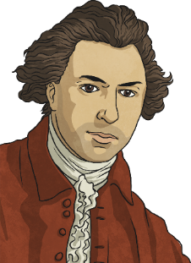 | Joseph Banks was an English scientist who studied plants. He became famous when he took part in Captain Cook's first voyage to Brazil, Tahiti, New Zealand and Australia. He was President of the Royal Society for 41 years, and advised King George III on how to set up the Royal Gardens at Kew.
David Douglas  1799-1834  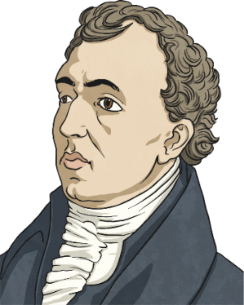 | David Douglas was a Scottish botanist who worked at the Glasgow Botanical Gardens and the Royal Horticultural Society in London. He took part in three trips from England to North America. He introduced the Douglas fir in 1827, as well as several other pines and fir trees. Douglas died on an expedition to Hawaii while climbing a mountain called Mauna Kea.
Tom Hart-Dyke  1976 - Present  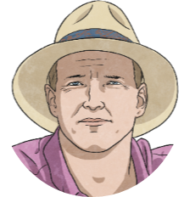 | Tom Hart-Dyke is an English horticulturalist and plant hunter. He is the designer of the World Garden at Lullingstone Castle (which contains around 8000 species of plants, many collected by Hart Dyke himself). Unfortunately, Tom was kidnapped on an expedition to collect a rare orchid in South America. Upon his release, he returned home and created his World Garden. He still hunts rare plants today.

Possible Scientific Enquiry Questions…
Observing over time | How is water distributed around the plant after it has been absorbed by the root?
Pattern seeking | Do all plants grow at the same rate?
Identifying, classifying and grouping | Can you identify the parts of the plant and think about its purpose?
Fair testing | Can you measure the growth of a plant fairly?
Scientific skills and enquiry (Year 3 and 4)

- Ask relevant questions and use different types of scientific enquiries to answer them.
- Set up simple practical enquiries, comparative and fair tests.
- Make systematic and careful observations and, where appropriate, take accurate measurements using standard units, using a range of equipment, including thermometers and data loggers.
- Record findings using simple scientific language, drawings, labelled diagrams, keys, bar charts and tables.
- Gather, record, classify and present data in a variety of ways to help in answering questions.
- Identify differences, similarities or changes related to simple scientific ideas and processes.
- Report on findings from enquiries including oral and written explanations, displays or presentations of results and conclusions.
- Use straightforward scientific evidence to answer questions or to support their findings.
- Use results to draw simple conclusions, make predictions for new values, suggest improvements and raise further questions.

